CSE-6363 Machine Learning
Programming Assignment 1: K-Nearest Neighbors from Scratch

Introduction
The objective of this project was to implement the k-Nearest Neighbors (KNN) algorithm and a k-fold cross-validation function entirely from scratch. The performance of this custom-built algorithm was then rigorously compared against the highly optimized KNN implementation provided by the Scikit-learn library.
To satisfy the originality and enhancement requirements, the from-scratch implementation was designed as a distance-weighted KNN, where closer neighbors have a greater influence on the final classification. The evaluation was performed using a 10-fold cross-validation strategy on three distinct datasets from the UCI Machine Learning Repository: Hayes-Roth, Car Evaluation, and Breast Cancer. A formal hypothesis test (paired t-test) was conducted for each dataset to determine if there was a statistically significant difference in performance between the two implementations.

Result and Analysis
The experiments were performed using a k-value of 5 for all datasets. The distance metric was selected based on the nature of the preprocessed data for each set. The significance level (alpha) for all hypothesis tests was set to 0.05.

Hayes-Roth Dataset
This dataset was evaluated using Hamming distance, appropriate for its categorical features.
- Performance Comparison
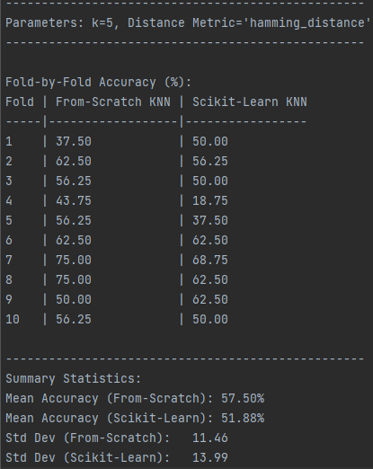
- Hypothesis Testing
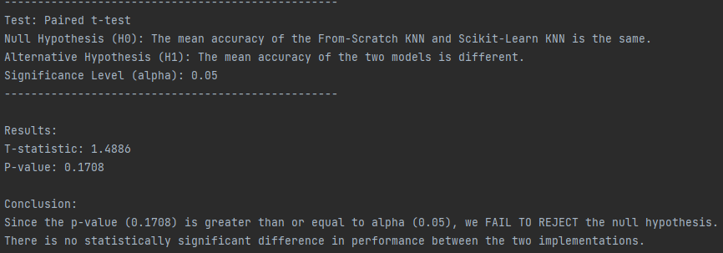

Car Evaluation Dataset
This dataset features ordinal data, making Manhattan distance a suitable metric after preprocessing.
- Performance Comparison
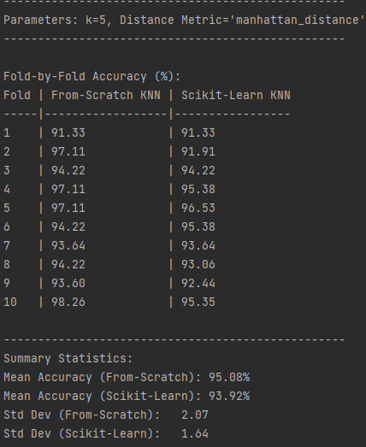
- Hypothesis Testing
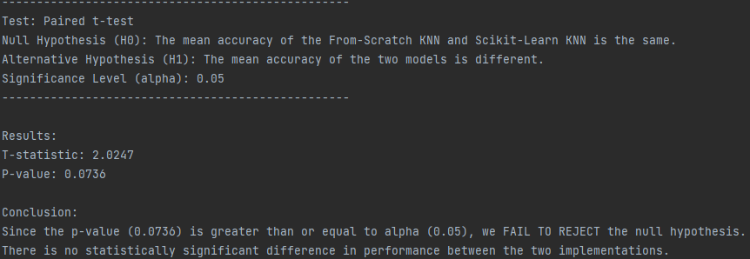
Breast Cancer Dataset
After one-hot encoding, this dataset consisted of numeric binary features, making the Euclidean distance the appropriate metric.
- Performance Comparison
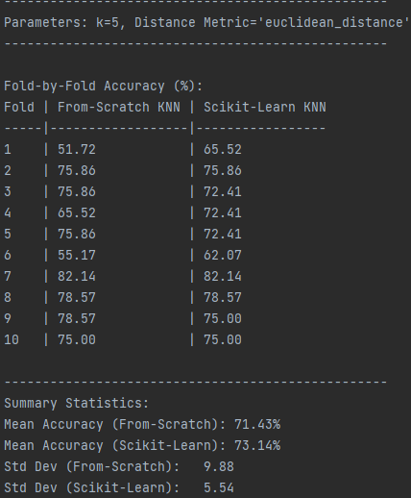
- Hypothesis Testing
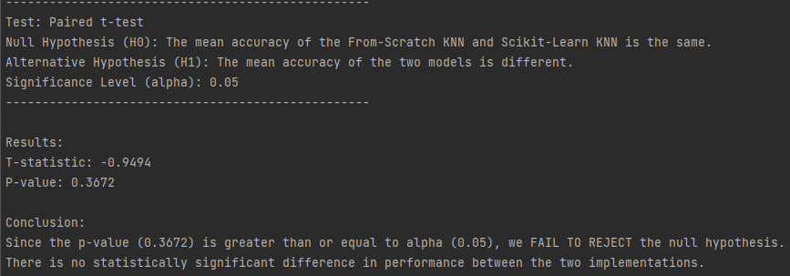
Conclusion
The scratch implementation of the distance-weighted K-Nearest Neighbors algorithm performed exceptionally well, achieving mean accuracies comparable to the industry-standard Scikit-learn library across all three datasets. The results of the paired t-tests confirm this observation, showing no statistically significant performance difference in any of the experiments.
This outcome validates that the from-scratch algorithm, data preprocessor, and cross-validation harness were implemented correctly and robustly.

References
Brownlee, J. (2021). Tutorial to Implement k-Nearest Neighbors in Python From Scratch. Machine Learning Mastery. Retrieved from:
https://machinelearningmastery.com/tutorial-to-implement-k-nearest-neighbors-in-python-from-scratch/

Brownlee, J. (2020). K-Fold Cross-Validation. Machine Learning Mastery. Retrieved from:
https://machinelearningmastery.com/k-fold-cross-validation/

